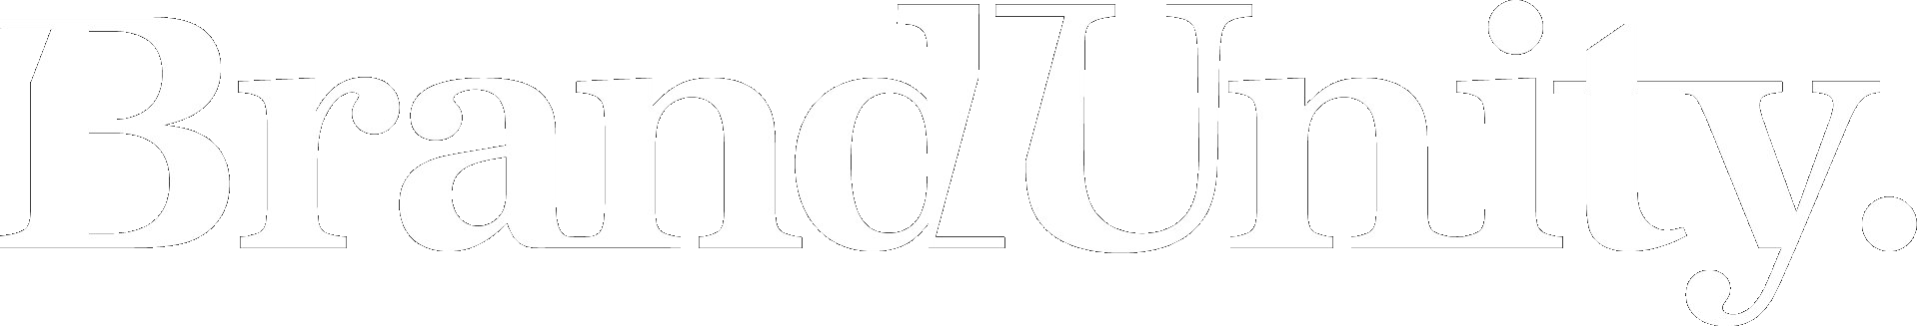

Ward6AI Platform
Word Document Formatter
Skill documentation

Brandunity · Skill 5 · v1 · May 2026

The Word Document Formatter applies Ward house style to a labelled draft to produce a publish-ready Word document. One brand-agnostic, ward-aware skill serves every Ward 6 and Ward 7 brand.

What it does
Writers and AI drafters produce labelled drafts — bracketed element tags such as [Head], [Body], [Callout] and [CTA] — that mark the hierarchy but carry no formatting. The studio then re-keys them into a house-style template by hand, which is slow and drifts across documents.
This skill takes a labelled draft and produces a publish-ready Word document with Ward house style applied: cover sheet, page header and footer, per-element fonts and spacing, page numbering, margins and a standard mandatories block. The writer’s copy is preserved verbatim; only formatting and document structure are added.
It formats only. It does not edit, rewrite or improve copy, check claims, or proof-check.

How to use it
Trigger it with “format this draft”, “apply Ward house style” or by submitting a labelled draft. The skill detects the brand, then prompts once for ward, document type and any missing cover details. It supports six built-in document types (HCP email, EDM, detail aid, eDA brief, case study, training) plus a generic fallback.
Element hierarchy is read from explicit bracketed labels first, then formatting cues, then context. Anything ambiguous is given best-guess formatting and flagged inline (yellow highlight plus a [FLAG] prefix) and in an opening summary. Image placements are rendered as text placeholders for the studio to source.

What it loads
One small file per brand, loaded from the shared Skill references folder at run time:
- <Brand> Brand Values.md — sponsor name, address, phone, website, ABN, and the fallback mandatory disclaimer used when a draft omits its [Mandatories] block.
The structural visual spec (cover layouts per document type, footer templates, header patterns, per-element styling) is baked into the renderer, not held in a document.

Output
A single publish-ready Word document: cover sheet, an opening summary (brand, ward, document type, element counts and every flagged item), the formatted body, a running header where the document type uses one, a footer with live page numbering, and the mandatories block. Rendered deterministically by the render_formatted_document Lambda tool.

Section labels and multi-version structure
The renderer styles each block per its element type, but it does not print a visible label saying what the section is. Two numbered lists in a row would look identical to the reader, and references for two audience versions would concatenate into one ambiguous list. The skill prevents that by emitting two kinds of labelling block ahead of the content.
Section labels. Before each multi-item block — Subject lines, Preheader options, Footnotes, References, Mandatories — the skill emits a subhead carrying the canonical label ("Subject lines", "Preheader options", "References", "Mandatories"). Single-item blocks (Header, Subhead, Body, Callout, CTA, Figure, Caption) are already typed by their element, so no label is added above them; the writer's working-notation brackets ([SUBJECT LINES], [PREHEADER], [BODY], [CTA], [CITATIONS], [MANDATORIES]) are stripped on the way in.
Version separators. When a draft contains more than one audience version (typical of an Email Drafter output that produces both a GP and an Oncologist version), the skill emits a header at the start of each version with the audience name ("Draft: GP", "Draft: Oncologist"). All blocks for that version follow the header in source order, including their own section labels. Source order within each version is preserved exactly as the writer composed it.

Ward 6 visual fallback
Ward 6 has no published visual spec yet, so Ward 6 documents currently use the Ward 7 visual spec; the output header notes this. When Ward 6 publishes its visuals, the renderer branches on the ward and applies the matching spec.

Status: This consolidated, brand-agnostic version supersedes the earlier per-brand variants. It depends on the new render_formatted_document Lambda tool, which is pending deployment and gateway registration. The fallback mandatory disclaimers in the brand-values files still need MLR sign-off.

Worth knowing: All output must be reviewed and verified against the writer’s draft and the brand house style before being passed to the studio.

